
Interview Test
Senior Business Intelligence

Solutions by Rinez

Part 1: Forming SQL Queries
Q1: Find the lifetime total orders, total spent (gmv), unique items bought, earliest purchase date, last purchased date, average amount spent per order and average purchase price for the following buyer IDs and their purchased products’ main categories:
- 576123
- 123152
Expected output:
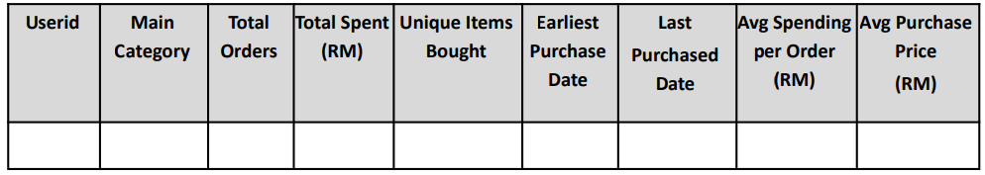
Solution:
SELECT
buyer_id,
COUNT(DISTINCT order_id) AS total_orders,
SUM(gmv) AS total_spent,
COUNT(DISTINCT product_id) AS unique_items_bought,
MIN(order_date) AS earliest_purchase_date,
MAX(order_date) AS last_purchased_date,
SUM(gmv) / COUNT(DISTINCT order_id) AS average_amount_spent_per_order,
(SUM(gmv) - SUM(shipping_fee_paid)) / SUM(qty_sold) AS average_purchase_price,
l1_cat AS main_category
FROM order_trans
JOIN buyer_profile ON order_trans.buyer_id = buyer_profile.buyer_id
WHERE buyer_id IN (576123, 123152)
GROUP BY buyer_id, l1_cat
ORDER BY buyer_id, main_category;

Q2: Find out the top 10 cross border items with the highest quantity sold last month, together with their tier **, minimum selling price, total spent (gmv) and total orders.
** Tier is a user-defined item attribute dimension with 3 unique values:
- Short Tail (>20 average daily orders)
- Mid Tail (between 10 - 20 average daily orders)
- Long Tail (< 10 average daily orders)
Expected output:
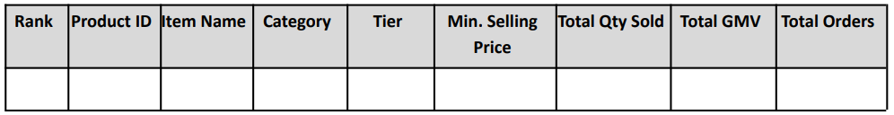
Solution:
WITH item_tiers AS (
SELECT
product_id,
CASE
WHEN AVG(qty_sold) OVER (PARTITION BY product_id) > 20 THEN 'Short Tail'
WHEN AVG(qty_sold) OVER (PARTITION BY product_id) BETWEEN 10 AND 20 THEN 'Mid Tail'
ELSE 'Long Tail'
END AS tier
FROM order_trans
WHERE is_cross_border = 1
)

SELECT TOP 10
product_id,
tier,
MIN(price) AS minimum_selling_price,
SUM(gmv) AS total_spent,
COUNT(DISTINCT order_id) AS total_orders
FROM order_trans
JOIN item_tiers USING (product_id)
WHERE is_cross_border = 1
AND order_date >= DATE_TRUNC('month', CURRENT_DATE - INTERVAL '1 month')
AND order_date < DATE_TRUNC('month', CURRENT_DATE)
GROUP BY product_id, tier
ORDER BY qty_sold DESC;

Q3: The following buyers purchased on Shopee on separate days and on several occasions:
- 123456
- 987654
- 34567
Find the average time (in hrs) between their first and second checkout in the last 120 days.
Expected output:
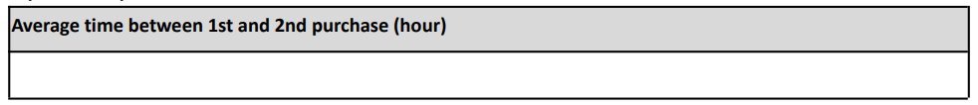
Solution:
WITH buyer_checkouts AS (
SELECT
buyer_id,
ROW_NUMBER() OVER (PARTITION BY buyer_id ORDER BY order_date) AS checkout_order,
order_date
FROM order_trans
WHERE buyer_id IN (123456, 987654, 34567)
AND order_date >= CURRENT_DATE - INTERVAL '120 days'
)

SELECT
buyer_id,
AVG(EXTRACT(EPOCH FROM (checkout_2_date - checkout_1_date))) / 3600 AS average_time_between_checkouts_hrs
FROM (
SELECT
buyer_id,
checkout_order,
order_date AS checkout_1_date,
LEAD(order_date, 1) OVER (PARTITION BY buyer_id ORDER BY order_date) AS checkout_2_date
FROM buyer_checkouts
) AS checkout_pairs
WHERE checkout_order = 1
AND checkout_2_date IS NOT NULL
GROUP BY buyer_id;

Part 2: Writing Pseudocodes & Python Codes
- Write a function that will be able to return the smallest positive integer missing from an unsorted array.
For example:
Input: [2, 3, -7, 6, 8, 1, -10, 15, -35]
Output: 4
Solution:
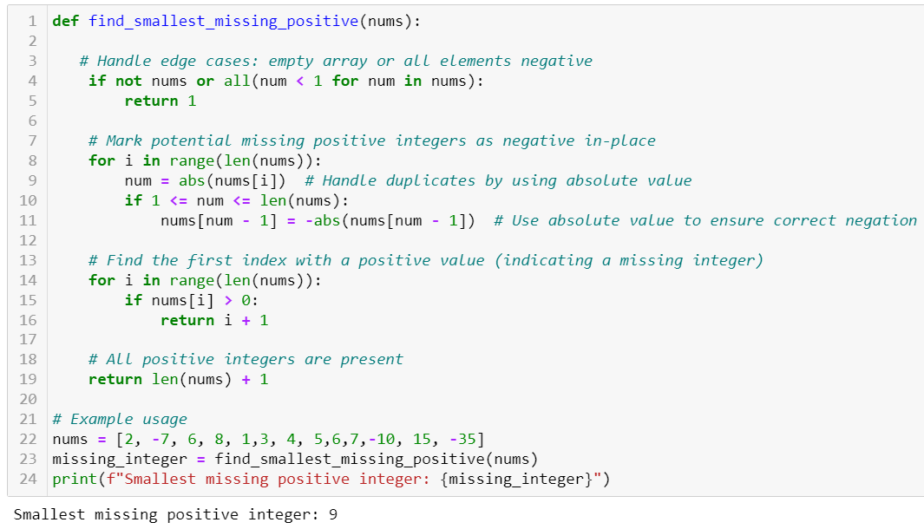
- Write a function that will be able to return the Nth element from the following sequence: 0, 3, 3, 6, 9, 15, 24, 39, 63, 102, 165,...
For e.g. if N = 3, output = 3 ; if N = 7, output = 24
Solution:
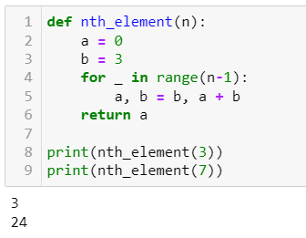
- Write a function that will be able to remove duplicates from a given array.
Output requirements:
- Array consists of a unique list of strings
- Ascending order
- First letter of each array element (string) capitalized
- All trailing and leading spaces removed
For example:
Input: [‘Panasonic’, pensonic’, ‘panasonic ‘, ‘Haier’, ‘electrolux ’, ‘ Electrolux’]
Output: [‘Electrolux’, ‘Haier’, Panasonic’, ‘Pensonic’]
Solution:
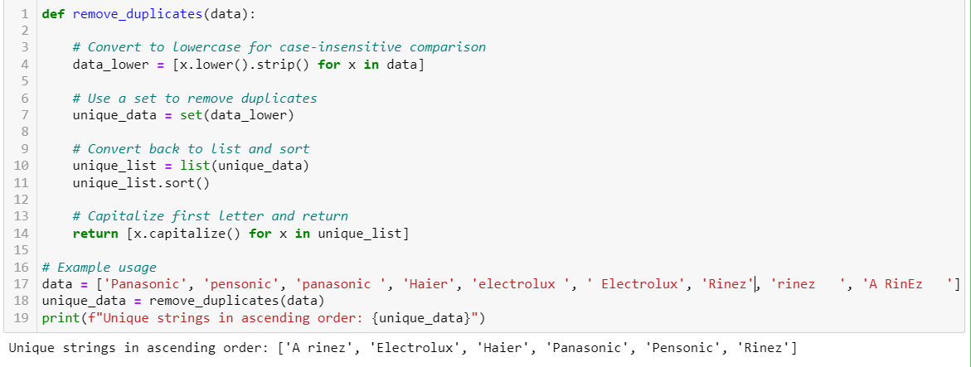

Part 3: Open-Ended Question
How would you develop data mart and data flow for rider incentive which will be used for the rider to check the incentive on daily basis.
Suggestions/Tips:
- A rider will have 4 factors: delivery point, pickup point, return point, and delivery successful point (% of monthly delivery successful)
- Incentives will be calculated cumulatively based on the sum of 4 factors
- Think about the daily and monthly maintenance (detail data and summary) and flexibility of monthly base rate changes
- Keep your answers structured
Solution:
Data Mart and Data Flow for Rider Incentive
Objective: Develop a data mart and data flow to manage rider incentives, allowing daily incentive checks and flexibility for base rate changes.
Factors:
- Delivery point: Number of successful deliveries (monthly)
- Pickup point: Number of pickups completed (monthly)
- Return point: Number of on-time returns (monthly)
- Delivery successful point: Percentage of successful deliveries from total deliveries (monthly)
Incentive Calculation:
- Cumulative: Sum of individual factor points weighted by their respective coefficients.
- Coefficients: Adjustable to prioritize specific factors.
Data Mart and Flow:
1. Data Sources:
- Operational Data Store (ODS): Real-time data on deliveries, pickups, returns, and success rates.
- Master Data: Rider information, base rates, coefficient values.
2. Data Staging:
- Extract data from ODS and Master Data at scheduled intervals (daily/hourly).
- Transform data into a consistent format:
  - Deduplicate entries.
  - Calculate monthly point values for each factor.
  - Apply coefficients to each factor.
3. Data Mart:
- Dimension tables: Rider, Time (date/month), Base Rate.
- Fact table: RiderIncentive (rider_id, date, delivery_points, pickup_points, return_points, delivery_success_points, total_points, incentive_amount).
- Aggregate data for daily checks: Calculate total points and corresponding incentive amount based on base rate and formula.
- Store monthly summaries for historical analysis.
4. Data Flow:
- ETL process extracts, transforms, and loads data from ODS and Master Data to the Data Mart.
- Scheduled jobs (daily/monthly) refresh data and recalculate incentives.
- API or UI interface allows riders to check their daily incentive based on ID and date.
5. Maintenance and Flexibility:
- Daily: Update Data Mart with new data, recalculate and store daily incentives.
- Monthly: Aggregate data for monthly summaries, update base rates if needed.
- Flexibility:
  - Adjustable coefficients to prioritize factors based on campaign goals.
  - Configurable base rate changes through Master Data updates.
6. Structured Response:
This structured response outlines the key components of the data mart and data flow for rider incentives:
- Data sources and their roles.
- Data staging and transformation process.
- Data Mart schema with dimensions and facts.
- Data flow and refresh schedule.
- Maintenance and flexibility considerations.
Additional Tips:
- Implement data quality checks to ensure accuracy and consistency.
- Consider caching frequently accessed data for performance optimization.
- Design dashboards and reports for incentive trends and analysis.
- Securely store and access sensitive rider data.
By implementing this data mart and data flow, you can provide riders with clear and accessible daily incentive information while maintaining flexibility for adjusting base rates and campaign priorities.

